
Beeford CE (VC) Primary School

‘All known, all cared for, all contributing’.
‘How good and pleasant it is when all God’s people live together in unity’
Psalm 133:1
Issue 140 25th March 2022
Dear Parents/Carers
Thank you for all of your support with charity events that have taken place this term, we were overwhelmed with your donations for the Ukraine appeal, donations for Comic relief and hot chocolate purchases. It was lovely to see the Fairtrade committee running their ‘shop’ again and we hope to repeat this in the Summer term.
We now look forward to Easter events in school please see below.
M J K Bell


Egg Rolling
This year the children will take part in an egg rolling competition here at school. We ask that they bring a plain hard-boiled egg in to school on Fri 8th April. There will be opportunities for children to decorate these in school before the competition. We will also be holding our annual Easter egg hunt in our houses. I wonder who will win this year.

The Big Battery Hunt
Thank you to all of you who have already collected batteries and returned them to school. There is a collection point in school so do keep sending them in.

Easter Collective Worship
As we continue to take small steps to ‘normality’ we will be taking the children to St. Leonards on Wed 6th April in the afternoon. Our collective worship will be led by Rev James but I am afraid this year it is for children only.

Outdoor Learning afternoon
On Tuesday 5th April all of the children will take part in a whole school outdoor Learning afternoon, weather depending. Please can your child come to school that day in suitable clothing and footwear. Thank you

Decorated Easter Egg Competition
This year we are holding a decorated Easter Egg competition in school. The school council have decided to continue with the World Book theme and ask that this year the eggs are characters from Fairy tales.
Please can your child bring their egg into school on Thur 7th April for the competition. The eggs will be judged in school by Mrs Winterbottom, Chair of Governors and will be on display at the end of the school day.

Credit Union School Bank
We have been asked by the credit union to find out parents views on reinstating the school bank.
Could you let the school office know if this is something you would be interested in using.
It would also be helpful for them to know the reasons why you would not use the service if it was to begin again.
Again, could you let the office know if it is because
- You do not want children bringing money into school
- This form of saving is now old fashioned and parents prefer to use electronic methods.
- Any other reasons.

FOBS Easter
Fobs will be holding an Easter raffle in the playground on Thurs 7th April at the end of the school day. Tickets will be available on the morning of the 7th at a cost of £1 each. If you would like to donate anything for the raffle please could they be in school by Tue 5th April. Thank you for your support.

E-safety
Unfortunately, many of you were unable to attend the online Parents e-safety meeting. Below is a link for you to watch at your convenience. In this ever increasing technological world I do urge you to find the time watch.
https://www.swgflstore.com/a/downloads/-/1844f3538de1c1bd/962e6a570eb62dd0

Science Workshop
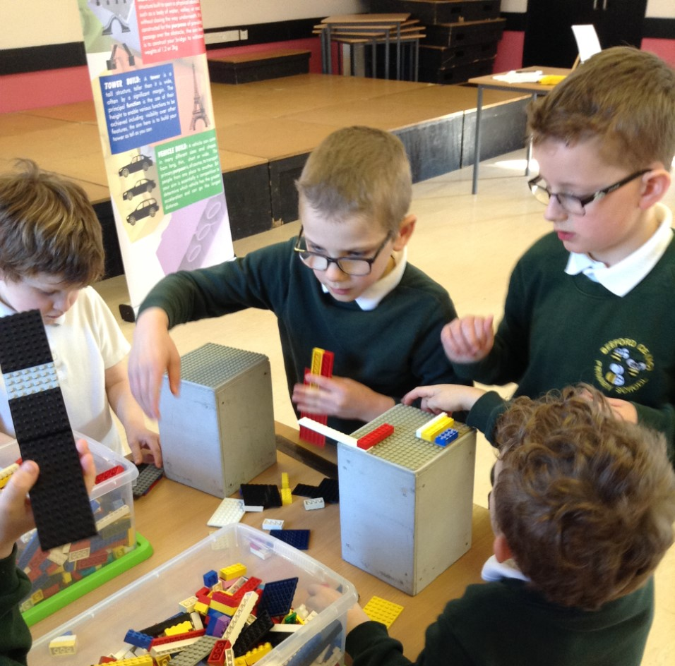
A big thank you to FOBS for providing the funds for the recent Science workshop for all children in school. The children thoroughly enjoyed it and although it wasn’t the Pantomime that we had originally wanted the children had lots of fun and worked really well together.

New Website
When you access our website in the future you will see that it has a new look. A big thank you to Miss Webster who has been very busy refreshing it. I hope you find it easier to navigate and the information useful.

Winning jokes
Thank you to all of the children who told a joke to their house on Comic Relief day. The winning joke was from Sienna in Year 3 and it went like this
Daddy Tomato, Mummy Tomato and Baby Tomato walking down the street. Baby Tomato can’t keep up so Daddy Tomato turns around squashes Baby Tomato and says ‘ketchup’.

Emails
As we have moved away from remote learning our class emails are checked less frequently. So, if you are making contact on an urgent matter e.g. to report an absence or update a picking up arrangement please use the office email of beeford.primary@eastriding.gov.uk
The class emails remain as follows
FSUadmin@beeford.eriding.net
Infantsadmin@beeford.eriding.net
Ljuniorsadmin@beeford.eriding.net
Ujuniorsadmin@beeford.eriding.net
headteacher@beeford.eriding.net

Diary Dates.
March
Mon 28th | Individual Photographs
Wed 30th | Year 1 / 2 to Sideoven Bakery  Year 3 / 4 to Yorkshire Wildlife Park
April
Tue 5th | Whole school outdoor Learning afternoon
Wed 6th | Collective Worship at St.Leonards
Thur 7th | Decorated egg competition  FOBS Easter event after school
Fri 8th | Break-up for Easter  Egg rolling and Easter Egg Hunt

Term Dates
Spring Term 2022
Training Day Tue 4th January
Term Starts Wed 5th January
Half Term 21st – 25th February
Term Ends Fri 8th April

Summer Term 2022
Term Begins Mon 25th April
Half Term 30th – 3rd June
Training Day Mon 6th June
Term Ends Fri 22nd July

