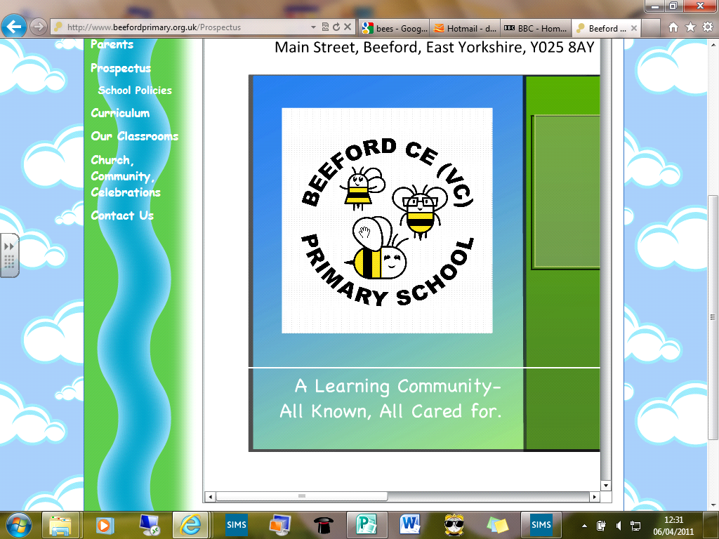
Beeford CE (VC) Primary School

‘All known, all cared for, all contributing’.
‘How good and pleasant it is when all God’s people live together in unity’
Psalm 133:1
Issue 112 3rd April 2020
Dear Parents/Carers
I hope all is well with you and your families; it has been lovely to connect with you this week either on the phone or by email and thank you so much to for all of your lovely messages of support for the school and the staff.
As we move in to what would have been the Easter holidays I hope that you and your families manage to have some downtime. There really is no expectation to continue with the school work over this time but obviously if you are in a routine and want to carry on then do.
Teachers are still contactable by the emails below, if needed, but I have asked staff to make sure that they too have time to rest and spend time with their families.
We of course await further direction from the Government to the length of school closures and we will be in touch after the Easter period with further support on how to continue with home learning if needed.
I hope you manage to have a lovely Easter and that the weather will be kind to us.
M J K Bell

Emails
I am sure that your child’s teacher has already been in touch with you but below is a reminder of the emails for us. Please do not hesitate to contact us and we aim to reply to you in a timely manner.
FSUadmin@beeford.eriding.net
Infantsadmin@beeford.eriding.net
Ljuniorsadmin@beeford.eriding.net
Ujuniorsadmin@beeford.eriding.net
headteacher@beeford.eriding.net

Free School Meals
We have been patiently waiting for further guidance from the Government on the best way to provide Free School Meals for eligible children in school. We are now clearer that this is for the children who are currently entitled to it and not for children who may have been eligible in the past or the younger children (UFSM). We are currently using the Government preferred voucher scheme. If you think you should have had an email about this and haven’t than please get in touch.
If you think your child may be entitled to a Free School Meal and you have never applied before please contact the council directly and then let us know the outcome please. We are unable to do this part for you.

Holy Week Resources
Please also find attached ideas from the Diocese to celebrate Easter whilst at home. I particularly like the Garden ideas.

Website
It has been so lovely to receive photographs from you of the work that you have been doing at home. You will find some of these on the website.
A reminder that our website address is https://www.beefordprimary.org.uk/ where you will find a home learning tab. This will evolve as we go on but please keep checking.
I also wanted to share this wonderful poem by Ellie-Mae in Year 6 with you all. It has really moved us all.



