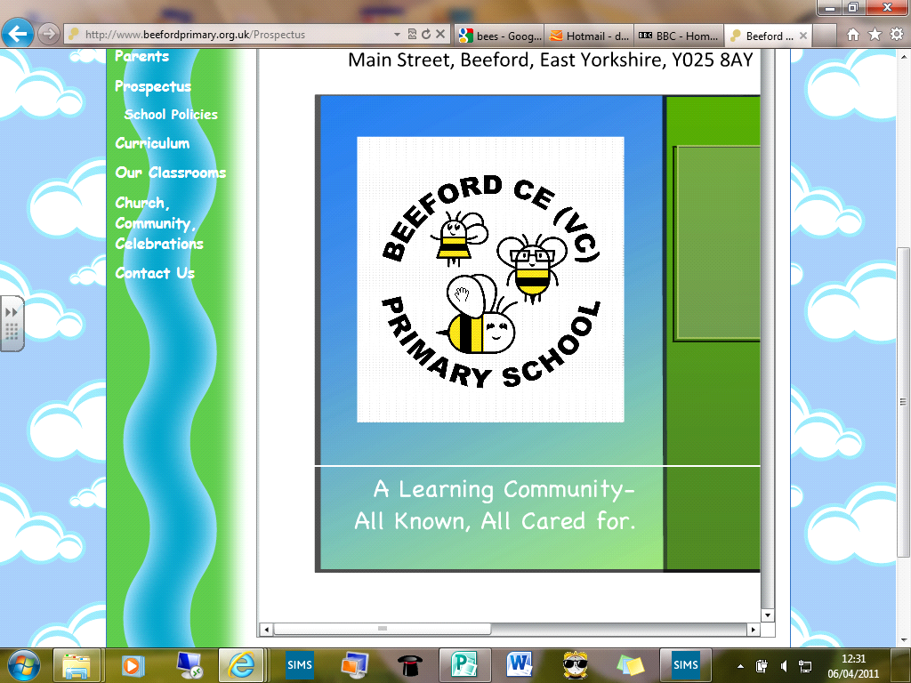
Beeford CE (VC) Primary School

‘All known, all cared for, all contributing’.
Issue 104 17th October 2019
Dear Parents/Carers
I can’t believe we are nearly at the end of the first half term. When we return we will soon be in the swing of, dare I say, Christmas. Thank you to all of you who supported the children at the Harvest Festival and the work of the Driffield Foodbank. It was much appreciated.

Miss Bates
I am really sorry to let you know that Miss Bates will be leaving us at the end of this half term as she is taking up a position at the Children’s Centre so we hope to still see her. She will be greatly missed by us all and we thank her for all she has done for our school and the children.

Charities
The children have put their ideas forward and we have chosen Viking FM’s Cash for Kids as our school charity this year. This is a local charity supporting sick, disabled and disadvantaged children in East Yorkshire and Northern Lincolnshire. We will be holding a special assembly in early November and the first event will be Mission Christmas, where we ask the children to donate a gift for children who may not be as fortunate as them.

Volunteer Helpers
As ever we are always on the lookout for helpers within school. If you do have some time to spare please ask in the office it would be very much appreciated. Thank you

Training Day
Please note that there is a training day on Friday 25th October so school will close for half-term on Thursday 24th October.

Forms and letters
I appreciate that we often send a lot of letters home for your consent as we broaden the curriculum for your children and ensure their safety. Please could you help us by returning any paperwork swiftly as it is taking a lot of office hours chasing missing consents and sending repeated letters. Thank you for your support with this.

Carol Service
Please note in your diaries our Carol Service on Tue 17th Dec at 10.00am at St. Leonards. This year we are doing something a little differently from our usual Nativity. I do hope you can come and join us for the singing. Some parents have asked about the FS1 children who are normally a big part of the Nativity. They will still have a starring role in this service and FSU staff will have more details to you soon.

Vision
We have been refreshing our vision with our children. Please could you talk to your child on how this is lived in our school they can give you lots of examples. As a Church school our vision is rooted in theology. The staff and Governors have spent some time looking at this please see below.
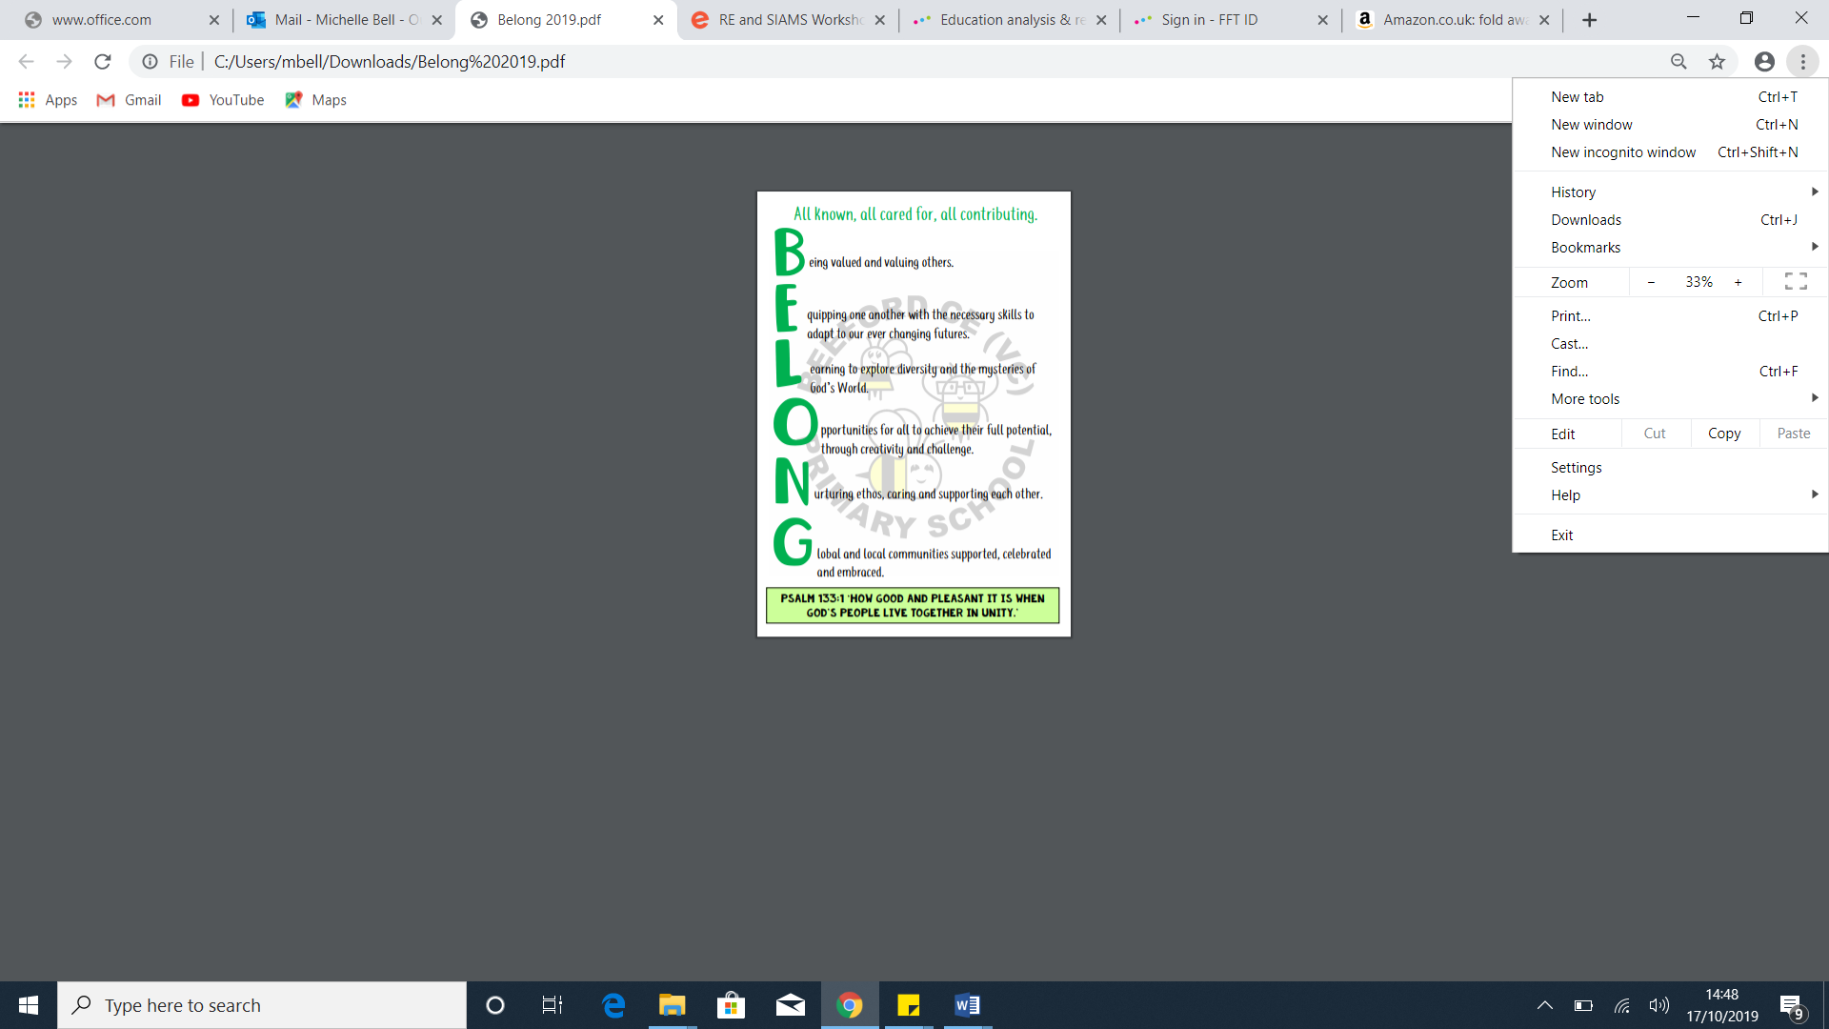

Diary Dates
October
Mon 21st | Diwali week
Wed 23rd | WOW day for Year 1 / 2
Thur 24th | Break up for half-term
Fri 25th | Training Day
November
Mon 4th | Children return to school  Parliament week
Tue 5th | Last day for online Cauliflower Card Orders
Mon 11th | Anti-Bullying Week
Tue 12th | Remembrance
Fri 15th | Children in Need
Wed 20th | Last swimming session
Fri 22nd | Beeford Stay and Play
December
Mon 2nd | Christmas Post Box in school
Fri 6th | Christingle day
Tue 10th | Christmas Play 2.00pm
Wed 11th | Christmas Play 6.00pm
Thur 12th | Christmas Play 6.00pm
Fri 13th | Beeford Stay and Play
Mon 16th | School Party in school
Tue 17th | Carol Service at 10.00am at St. Leonards
Fri 20th | Pantomime Trip  Break-up

Term Dates
Autumn Term 2019
Training Day Mon 2nd September
Term Begins Tue 3rd September
Training Day Fri 25th October
Half Term 28th – 1st November
Term Ends Fri 20th December

Spring Term 2020
Training Day Mon 6th January
Term Begins Tue 7th January
Half Term 17th – 21st February
Term Ends Fri 3rd April

Summer Term 2020
Term Begins Mon 20th April
May Day Fri 8th May
Half Term 25^{th –} 29th May
Training Day Mon 1st June
Term Ends Fri 17th July

