
Beeford CE (VC) Primary School

‘All known, all cared for, all contributing’.
Issue 100 10th June 2019
Dear Parents/Carers
This is a very special newsletter as it’s the 100th one that I have written over my 8 years as Head at Beeford CE (VC) Primary School. It continues to be a pleasure and a privilege to lead this special school and I believe we really do have the very best staff, children and Governors.

Here is a wordle of the first words that all of the children thought of when asked about our school. Each child has also contributed to the newsletter with a picture of themselves.
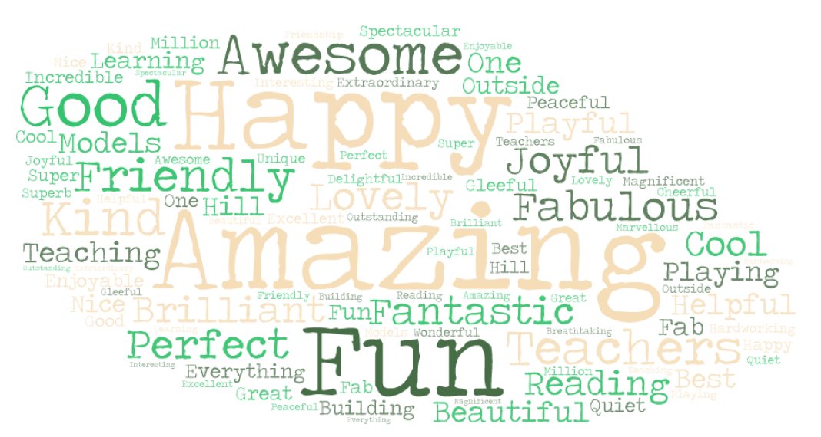

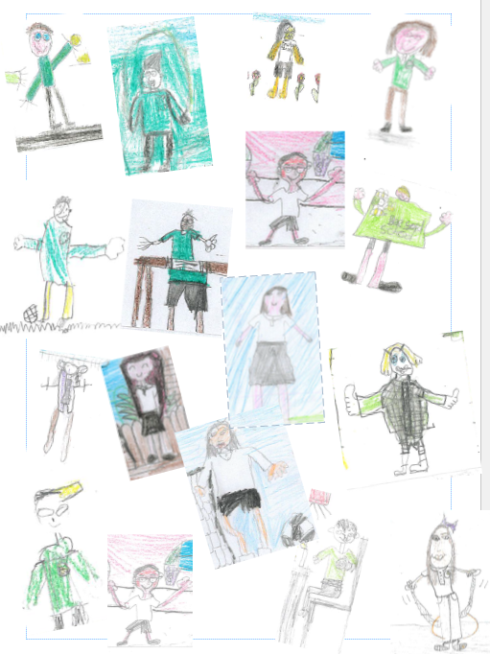
Quality Mark
I am delighted to let you all know that the school has been awarded a Quality Mark for the third time. The assessors were so complimentary about the school particularly about the children who showed them around. They recognised that they were so proud of their learning environment. They were also impressed with our school curriculum. They said;

‘The ethos of the school supports a kind and sharing environment. All children and staff enjoy and embrace school life with enthusiasm and are extremely well motivated to achieve their full potential through the vision and drive of the Head Teacher and SLT team.’

Beeford’s Got Talent
Beeford’s Got Talent will take place in school on Wed 3rd July. The signing up sheet will be going up shortly. The winner will be performing at the leaver’s / end of year assembly.
Sports day
Our Sports day this year is on Wed 19th June
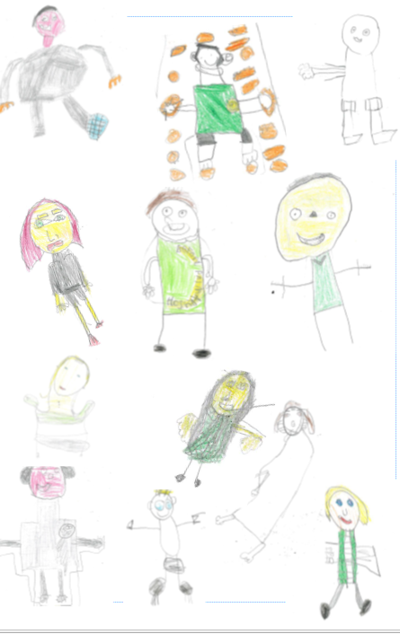
10.00am start for FS1 / FS2 / Year 1 and Year 2
2.00pm start for Year 3 / 4 / 5 / 6
Friends of School will be serving refreshments at both events.
Your child may wear sports clothes all day. Please can your child wear a T-shirt in their house colours.
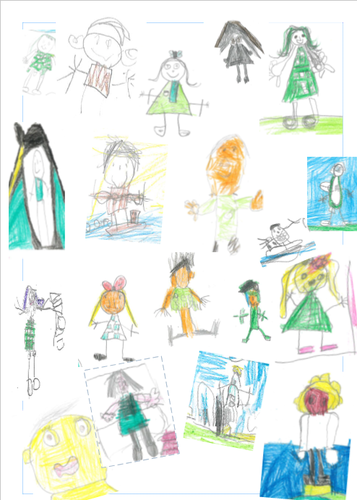
Meteors – Red
Shooting Stars – Blue
Comets – Green
Asteroids – Yellow
Please can FS1 children come in a PE kit.

Summer Sports Dates
Wed 19th June | Multi-skills Festival | Y1/2 | Hornsea Primary School
Thur 27th June | Skipping Festival | Y2/3 | Hornsea Primary School
Wed 3rd July | Rounders | Y5 / 6 | TBC
TBC | Cross Country | Y1 – 6 | Hornsea Secondary School

Summer Fair/ BBQ
The Summer Fair and BBQ this year will be on Fri 28th June at 5.30pm – 7.30pm. I do hope you can join us. There is no need to buy tickets in advance; they will be available to buy on the evening. £3.00 will get you a hot dog or burger and a drink. Let’s hope the sun shines and see you all there.

Leavers / End of Year Assembly
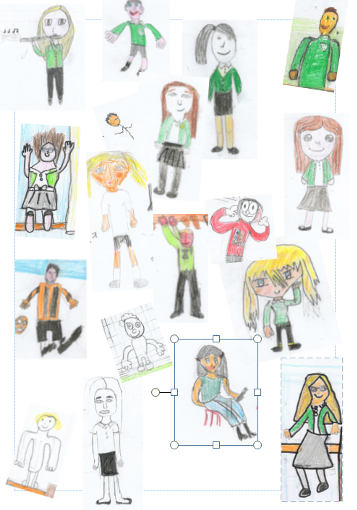
As usual this will be a Celebration of the whole year in school as well as the Leavers assembly. So all parents are welcome to join us but priority seating is given to the Year 6 parents. This will start at 1.15pm and will leave time for the Year 6 parents to join us back in school for tea and cake before we say our final farewells. I hope that you will be able to join us. The children are keen as ever to have a water fight at the end of the day and the Year 3 / 4 / 5 children are also keen to be involved. If you are happy for your child to take part in this, please can they come prepared as they will get wet. If your child does not want take part, please let us know.

Year 6 Leavers ‘Performance’
This year the Year 6 end of year performance will be more film based. The Year 6 children are busy writing it at the moment but assure me it will be a lighter look at school life. This will involve the Year 5 children too. I do hope you can join us on Wed 10th July (timings to follow) for its premiere.

End of year party
This year we will be celebrating the end of year with a ‘party’ afternoon in school on Mon 15th July. Please can your child come in non-uniform party clothes on that day.

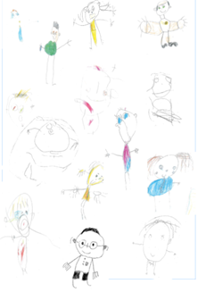
Diary Dates
June
Mon 10th | Growing Up talk for Year 6
Tue 11th | Freestyle Football
Wed 19th | Sports Day  FSU / KS1 am  Lower Juniors / Upper Juniors pm
Fri 21st | Year 6 Science morning at Hornsea
Fri 28th | Summer Fair
July
Mon 1st | Leavers Service at Beverley Minster for Year 6
Tue 2nd | Stone Age trip for Year 3 / 4
Wed 3rd | Parents drop in evening 3.30 – 6.00pm
Fri 5th | Beeford’s Got Talent
Mon 8th | Little Big Sing pm
Tue 9th | Big Sing pm
Wed 10th | Year 6 leavers evening
Thur 11th | Kinetic Science production
Mon 15th | Party afternoon
Wed 17th | Driffield Show
Fri 19th | Leavers Assembly pm  Break up

Term Dates
Summer Term 2019
Term Begins Tue 23rd April
May Day Mon 6th May
Training Day Fri 24th May
Half Term 27^{th –} 31st May
Term Ends Fri 19th July

Autumn Term 2019
Training Day Mon 2nd September
Term Begins Tue 3rd September
Training Day Fri 25th October
Half Term 28th October – 1st November
Term Ends Fri 20th December

