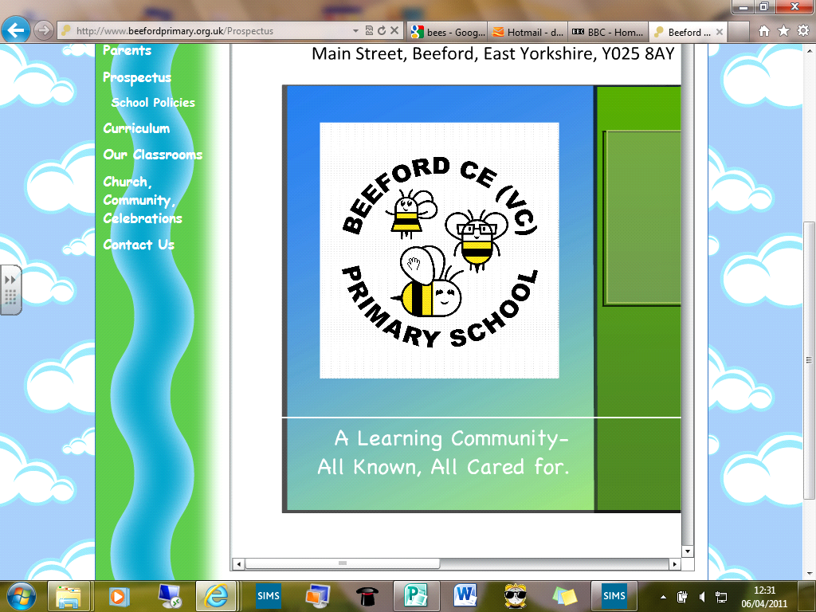
Beeford CE (VC) Primary School

‘All known, all cared for, all contributing’.
Issue 80 9th June 2017
Dear Parents/Carers
I can’t believe we are in the last half term of the Summer term and that we will soon be saying goodbye to our Year 6 children. We have been so proud of the way in which they coped with the pressure of Year 6 SAT’s, continued to smile and some even said they ‘enjoyed doing them’! As ever this is a fun packed seven weeks so please check below for more details of some of the events we have planned.

Sports day
Our Sports day this year is on Wed 21st June
10.00am start for FS1 / FS2 / Year 1 and Year 2
2.00pm start for Year 3 / 4 / 5 / 6
Friends of School will be serving refreshments at both events.
Your child may wear sports clothes all day. Please can your child wear a T-shirt in their house colours.
Meteors – Red
Shooting Stars – Blue
Comets – Green
Asteroids – Yellow
Please can FS1 children come in a PE kit.

Kids Club
The next dates for Kids club with Rev James are:
14th June
28th June
12th July
For more details please ask in the office.

.

Summer Fair
This year our Summer Fair and BBQ will be held on Friday 16th June at 5.30pm – 7.30pm. This year there is no need to buy tickets in advance; they will be available to buy on the evening. £2.50 will get you a hot dog or burger and a drink. Let’s hope the sun shines and see you all there.

House Captains
Well done to all of the children who took part in the House Captain elections in school. They all did exceptionally well with their election speeches and posters. There can of course only be one winner for each house and the following have been duly elected.
Shooting Stars – Reuben (Year 4)
Meteors – Joe (Year 1)
Comets – Sam (Year 5)
Asteroids – Katy-May (Year 5)
I look forward to hearing their ideas and seeing their plans come to fruition.

Beeford’s Got Talent
This year Beeford’s got talent will take place on Fri 14th July. The children will have chance to sign up in school and I look forward to letting you know the winner.

Transition mornings
In past years we have found it particularly important for the children to spend time in their new classes before the new school year. This year the children will spend each morning in their new classes during the week beginning Mon 10th July. Our Year 6 children will spend the time completing transition units for Secondary School.

Nepal Fundraiser
We are always grateful for the super support you show for our class and school charities. I am conscious of keeping our links with Nepal that the children responded so well to. On Friday 30th June the children will be completing circuits of the school field that are equivalent to the height of Mount Everest (29,035ft / 8,848m). Our Upper Juniors children have been working this out for us and they inform me this would be 35 laps around. Nearer the time the children will be bringing pledge forms home and we hope you will support the work of Ian Banks in Nepal by sponsoring the children for their efforts. Half of the money will go to Nepal and half of the money will go to Beeford School Fund. I am hoping that Ian will also have his Nepal Shop with him after school too.

End of Year disco
This end of year disco is going to be held on Mon 17th July during school time. The children are able to come to school for the day in their ‘disco’ clothes. If you wish your F1 child to come to the disco, please could you let the office know by Fri 30th June so you can be invoiced accordingly.

Questionnaires
You may remember that our annual questionnaire was hosted through our website this year with only 3 responses. I attach a paper copy with this newsletter and I would appreciate responses by Fri 23rd June please. Your thoughts are important to us as a school and help to formulate future plans and policy. Thank you

End of Year Assembly / Leavers Assembly
As usual this will be a Celebration of the past year in school as well as the Leavers assembly. This will start at 1.15pm and will leave time for the Year 6 parents to join us back in school for tea and cake before we say our final farewells. I hope that you will be able to join us. The children are keen as ever to have a water fight at the end of the day and the Year 3 / 4 / 5 children are also keen to be involved. If you are happy for your child to take part in this, please can they come prepared as they will get wet. If your child does not want take part, please let me know.

Sports News
The netball team have continued to be unbeaten and have only two games remaining. Their achievements have been recognised and they are runners up in the 'Outstanding Team of the Year' category at this years East Riding awards evening. We also have two other children collecting awards for 'Outstanding PE' and 'Leadership'. We are very proud to have children receiving these awards for the first time. The school recently had success in orienteering with a team entering the next round after winning the local event. Keep up the brilliant work!

Cakes and Allergens
Thank you to all of you who have informed us of any food allergies that your child may have. Could I ask that you let us know of any new allergies as soon as you can so that we can keep our lists up-to-date in school. These lists are important as from time to time the children make and taste different foods in school and often people very kindly bring cakes in, especially on birthdays.
If you do bring any food into school, could we ask that you are able to list the ingredients to ensure that we are not giving children anything that they could potentially be allergic to.
We have been texting, as and when these occasions arise, but in future we will assume that you are happy for your child to have these occasional treats (allergies accepted) unless you have informed us otherwise. Thank you for your support with this.

Lower Juniors news
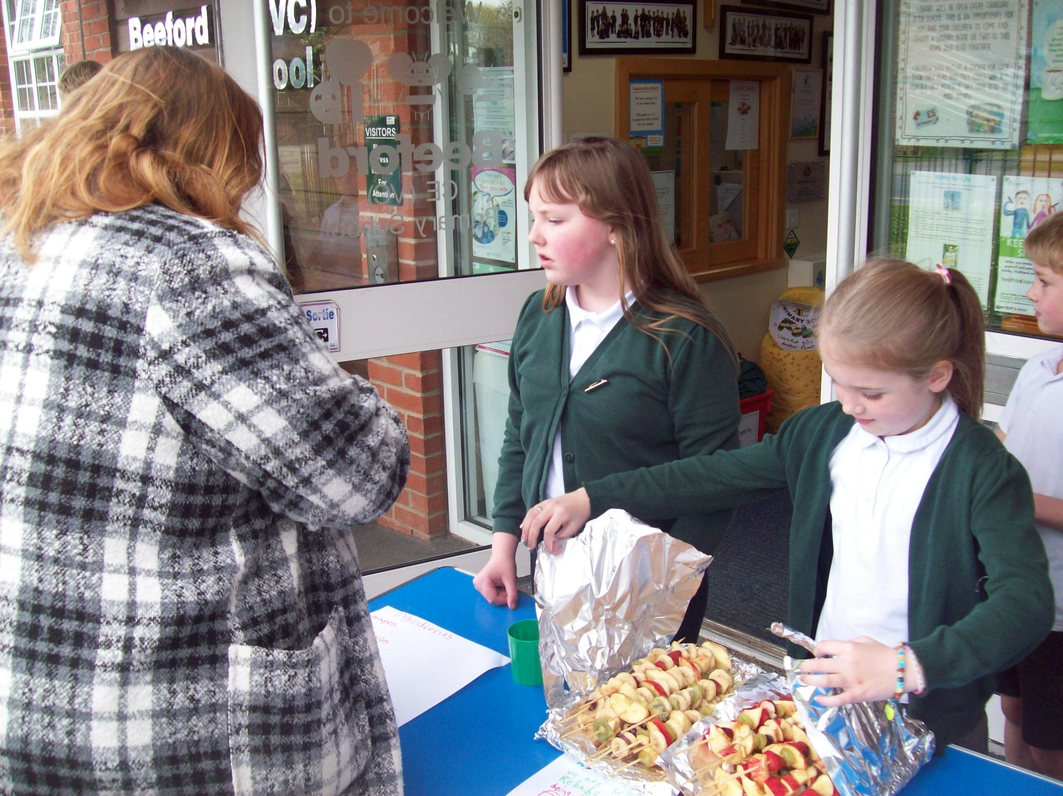
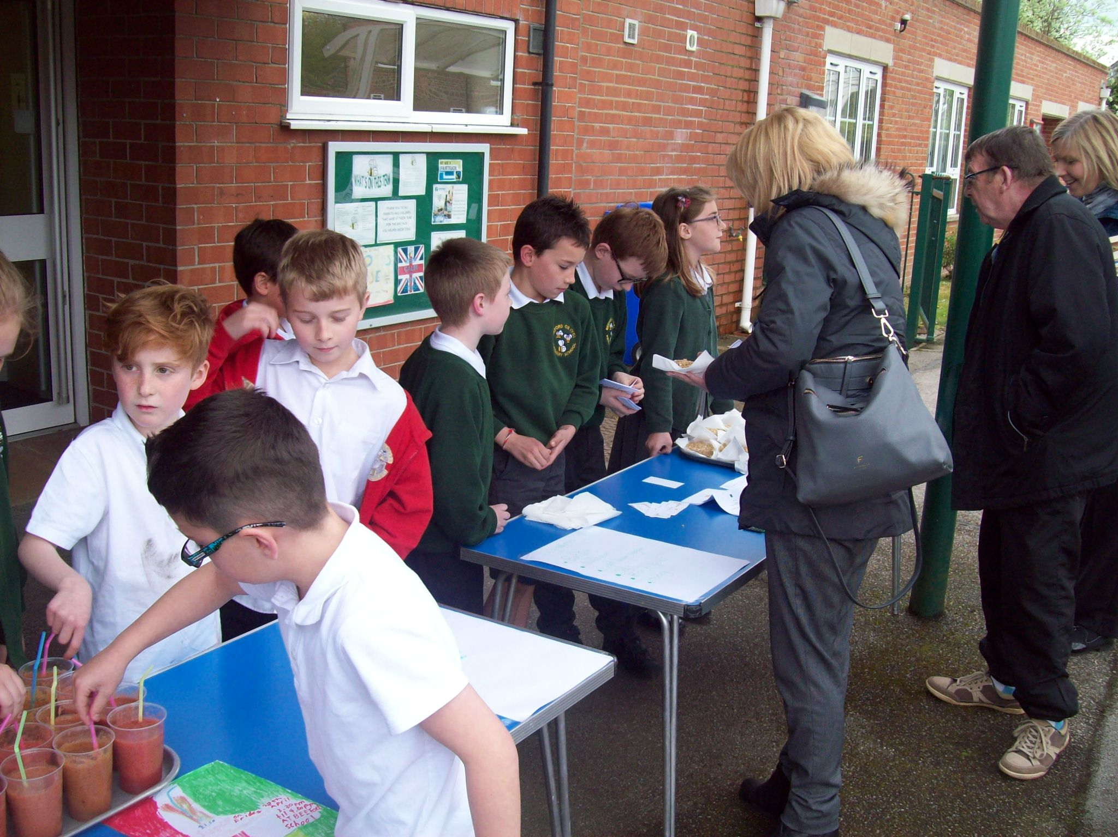
Thank you to everyone who came to support the Lower Juniors as part of their enterprise topic. As a class they raised £84 for their class charity - The Deep. The winning team were team four who were selling the cereal bars as they made almost £30 profit! We will be donating our money to The Deep when we visit them as part of our topic on the 29th June.

FSU help
If you find yourself clearing out at home and have any toy cars, dolls prams, wheeled toys or small world toys we would be very grateful in our FSU. These types of toys often get a lot of ‘hammer’ in school so replacements are always a bonus for us. Please see a member of the FSU team if you have anything that you think may be suitable. Thank you

Cookery Club News
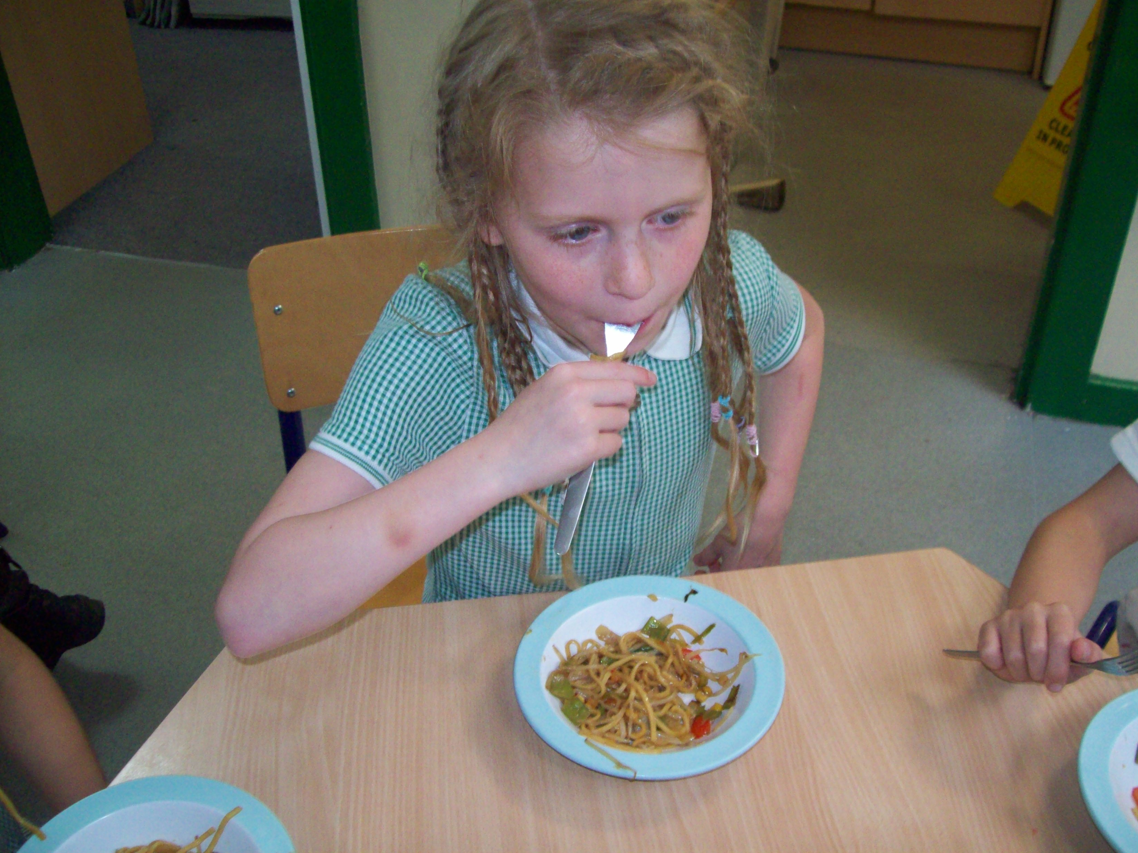
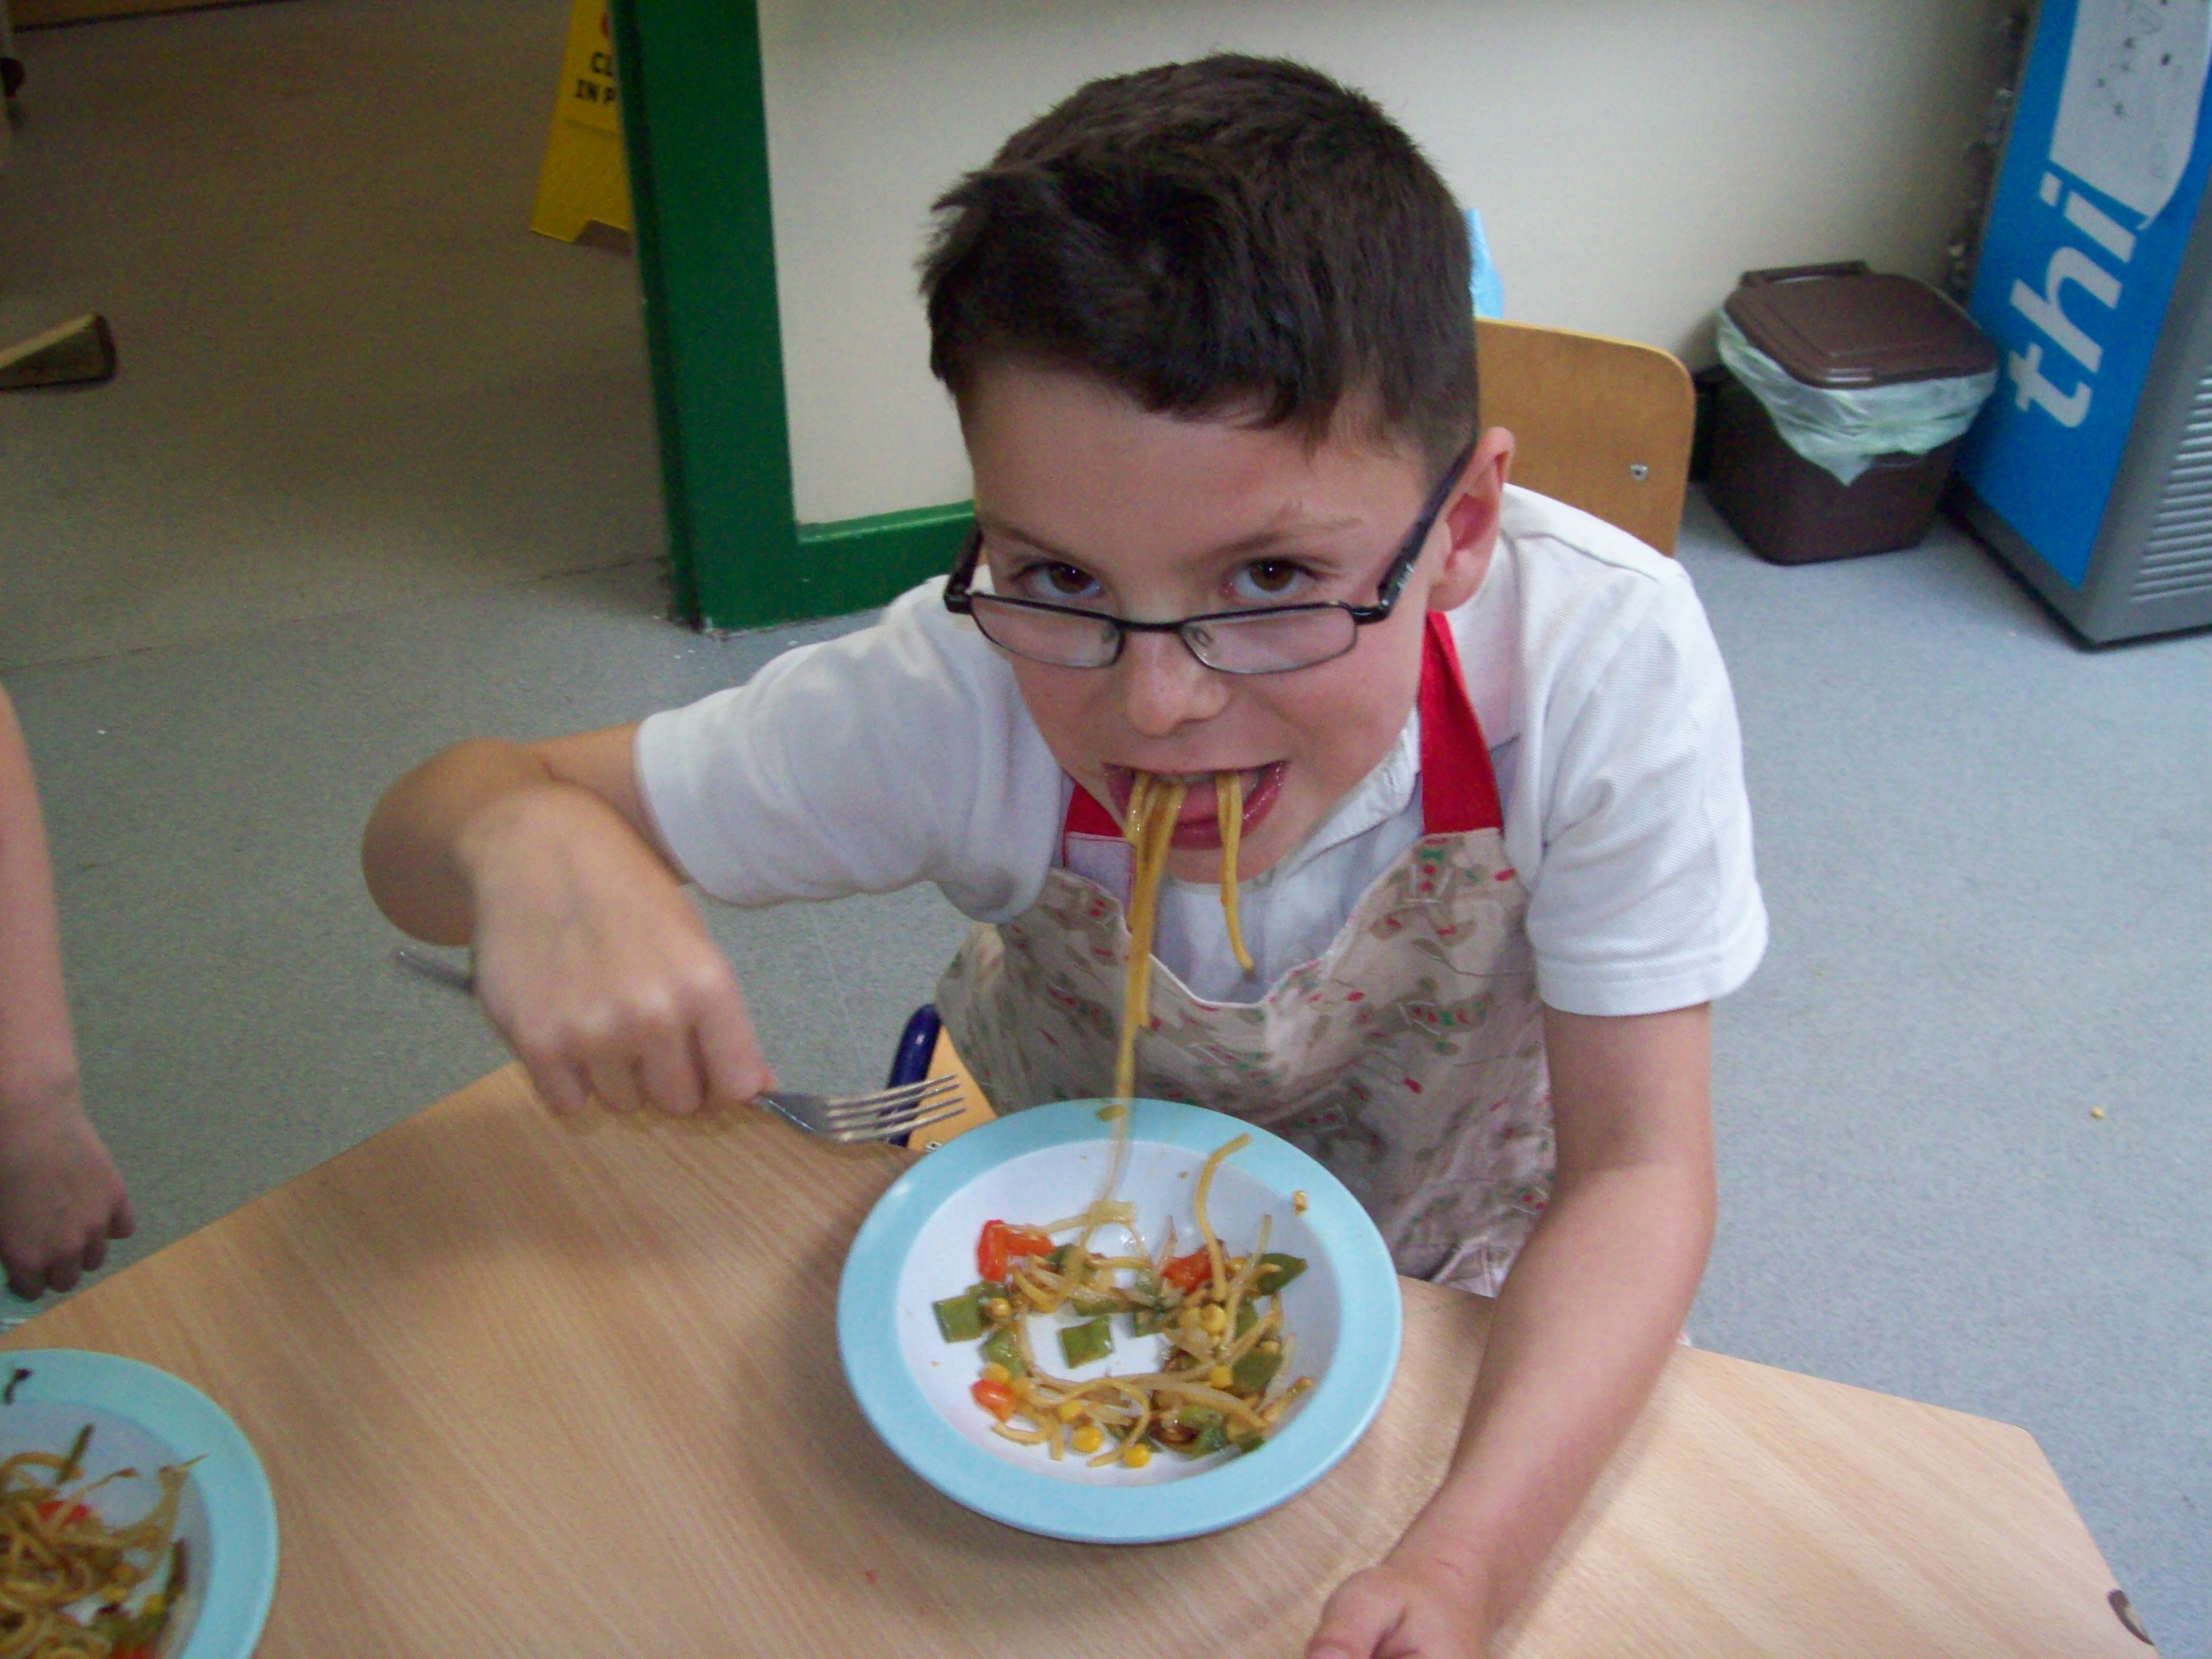
Cookery Club kicked off at the beginning of last term with the start of five weeks of exciting recipes. Group One made French Toast, American Pancakes, Muffin Pizzas, Pin Wheel Sandwiches and finished with Vegetable Chow Mein. They learnt how to correctly and safely use a knife to chop vegetables and use weighing scales. Throughout the five weeks they compiled their very own recipe book, designing the front cover and filling it with recipes and food quizzes

Diary Dates
June
Mon 12th | Phonics screening check week
Fri 16th | Summer Fair
Mon 19th | Work experience students start
Wed 21st | Sports Day
Tue 27th | RE Action Day for Year 5 / 6
Thur 29th | Year 3 / 4 trip to the Deep
Fri 30th | Nepal fundraiser pm
July
Mon 3rd | Little Big Sing pm
Tue 4th | Big Sing pm
Wed 5th | Year 6 production 6.30pm
Mon 10th | Science Theatre Company pm
Wed 12th | Parents Eve 3.30 – 6.00pm
Fri 14th | Beeford’s Got Talent
Mon 17th | Leavers / End of Year disco pm
Wed 19th | Driffield Show
Fri 21st | End of Year / Leavers assembly 1.15pm

Term Dates
Summer Term 2017
Training Day Mon 24th April
Term Begins Tues 25th April
May Day Mon 1st May
Half Term 29th May – 2nd June
Term Ends Fri 21st July

Autumn Term 2017
Training Day Mon 4th September
Term Begins Tue 5th September
Training Day Fri 27th October
Half-term 30th Oct – 3rd Nov
Term ends Fri 22nd Dec

Spring Term 2018
Training Day Mon 8th January
Term Begins Tue 9th January
Half Term 12th – 16th February
Term Ends Fri 23rd March

Summer Term 2018
Term Begins Mon 9th April
May Day Mon 7th May
Training Day Fri 25th May
Half Term 28th May – 1st June
Term Ends Fri 20th July

